Lab 1

In this week, we practice drawing flowcharts to know how to design a resolution strategy in order to solve the problem by computer. Students can see some sample exercises and must prepare solutions for all exercises in part B.

A. Sample exercises.

- Design an algorithm in flowchart to read and find maximum between 2 numbers.
Solutions:
Prototype: Max(float x, float y)
Flowchart:
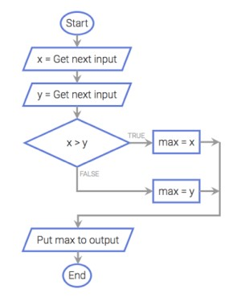
Figure 1. Determine maximum between 2 numbers

- Design an algorithm in flowchart to convert between meters and inches.
(Hint: 1 inch = 2,54 cm).

Solutions:
Prototype : floatconvert (float a,int sel);
//sel=1: inches to meter, sel ≠1: meter to inches

Flowchart :

Start
Input sel
m a*2.54/100
Print in meter: m
Stop
sel=1?
Yes
Input a
inc a*100/2.54
Input a
Print in inch: inc
No
Figure SEQ Figure \* ARABIC 2. Converter between meters and inches
Figure 1. Converter between meters and inches

- Design an algorithm in flowchart to calculate the diameter, circumference, and area of the circle of radius R.

Solutions:
Prototype : CircleDetail (float R);
Flowchart :

Start
Input R
d 2*R
p 2*3.14*R
s 3.14*R*R
Print d,p,s
Stop
Figure SEQ Figure \* ARABIC 3. Calculate diameter, circumference, and area of the circle of radius R

B. Exercises must to do.

- Design an algorithm in flowchart to find the smallest number in a group of three real numbers.

- Design an algorithm in flowchart to check whether a point A(x, y) is on, inside or outside the circle with center O(x0, y0) and radius of size R.

- Design an algorithm in flowchart to solve the quadratic equation: ax² + bx + c =0 with the inputs a, b, and c.

- Design an algorithm in flowchart to read in a group of N numbers and compute the average of them, where N is also an input.

- Design an algorithm in flowchart to determine if a triangle is equilateral, isosceles, right-angled or isosceles right-angled triangle when a,b,c - the lengths of three sides of this triangle - are given.

- Design an algorithm in flowchart to calculate the average of four grades of four subjects of a student and determine whether students “Pass” (>=60) or “Fail”.

C. Exercises in advanced.

- A set of linear equations:
aX + bY = c
dX + eY = f
can be solved using Cramer’s rule as:
X = (ce – bf)/(ae – bd)
Y = (af – cd)/(ae – bd)
Design an algorithm in flowchart to read in a, b, c, d, e and f and then solve for X and Y.

- Design algorithm to check if a given year is leap year or not.(Leap year is divisible by 4 but not by 100 or divisible by 400.)
Hint: leap year is the year divisible by 4 but not divisible by 100, or it is divisible by 400.

- Design an algorithm in flowchart to read and calculate factorial of integer N.

